

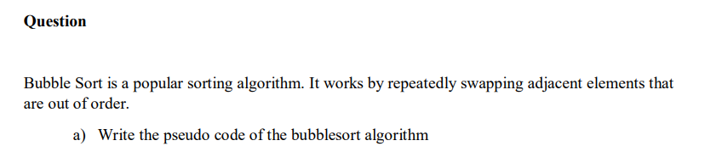

BUBBLESORT (A)

1. for i =1 to A.length-1
2. for j = A.length down to i+1
3. if A[j]< A[j-1]
4. Exchange A[j] with A[j-1]

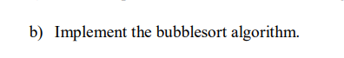



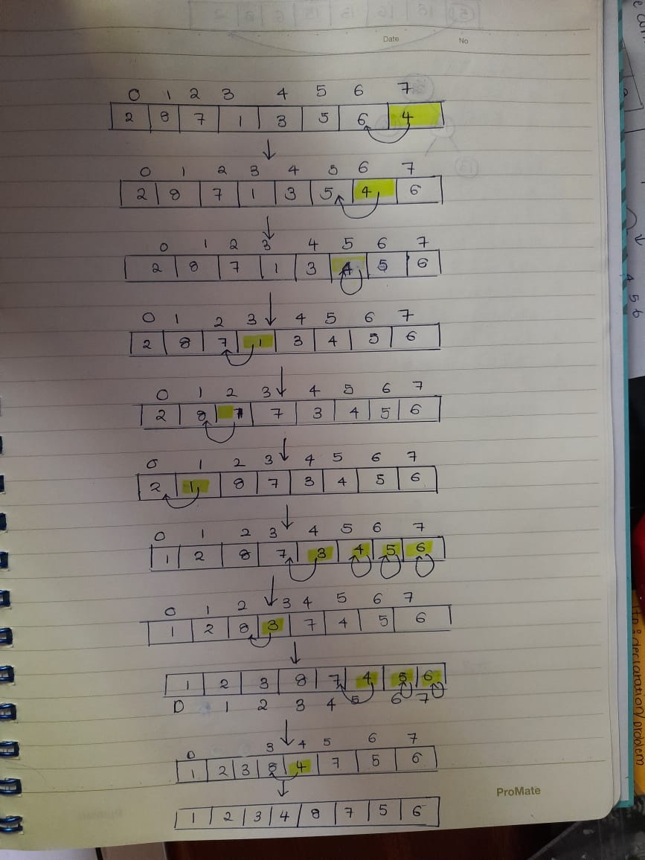

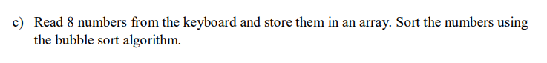



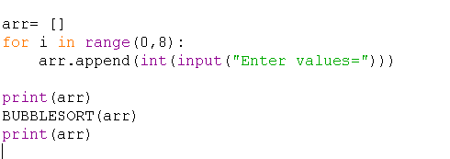

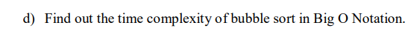

1. Since there is a loop inside another loop the Big O notation O(n2)